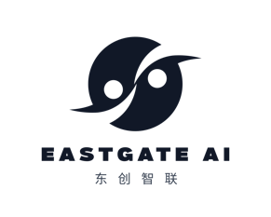 Client Requirement Form 3_ Innovation Immersion
Curated, insight-driven visits to China’s leading AI, digital, and robotics players..

1. Your Focus Areas (select top priorities)
- Livestream commerce / social commerce
- Robotics (warehousing, manufacturing, service)
- AI & data platforms
- E-commerce ecosystem (Alibaba, JD, etc.)
- Supply chain & logistics innovation
- Digital marketing & post-00 engagement
- Other: ________
2. Your Objectives
- What specific business challenges or questions do you want to address?
- Examples:
  - “How do Chinese brands use livestream to drive sales, and can we replicate that?”
  - “What are the latest robotics solutions for warehouse automation?”
  - “How do we partner with top AI firms for our R&D?”
3. Preferred Trip Details
- Preferred timing & duration
- Number of participants
- Any specific cities / regions (Shanghai, Shenzhen, Beijing, etc.)
- Special access needs (executive level, technical deep dives, factory tours)
4. What Success Looks Like
- Desired outcomes: (e.g., signed partnership, pilot project, strategic insights, supplier shortlist)
- Need for post-trip follow-up support?
5. Logistics & Support
- Will you use your own travel/logistics partners?
- Do you require full-service support (visa, accommodation, interpreters, ground transport)?
6. Existing China Relationships
- Have you visited China before?
- Do you already have contacts in the target ecosystem?
7. Budget & Timeline
- Approximate budget range (to help tailor options)
- Any deadlines (e.g., board meeting, strategy cycle)
8. Next Steps
- What would you like from us?
  - Initial itinerary proposal
  - Cost estimate
  - Introduction to specific players
  - Full trip management

