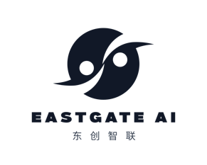 Client Requirement Form 2_ Cross-Border Digital Transformation
For multinationals seeking to integrate China’s digital speed, AI, and agile practices into their global operations.

1. Your Current Situation
- Industry sector (FMCG, luxury, manufacturing, etc.)
- Geography of operations (where are your China and global teams located?)
- Current digital transformation maturity / challenges
2. Strategic Objectives
- What is driving this initiative? (e.g., need to accelerate time-to-market, adopt AI, improve data-driven decision making)
- Is this for:
  - China-for-China (improving China operations)
  - China-for-global (offshoring digital capabilities from China)
  - Both
- Desired outcomes (e.g., faster product development, AI-powered insights, agile organization)
3. Areas of Focus (check all that apply)
- AI & data platform adoption
- Agile ways of working (scrum, DevOps, etc.)
- Digital talent & capability building
- Cross-border governance & integration
- Specific use cases (e.g., demand forecasting, supply chain optimization, personalization)
4. Existing Digital Landscape
- Key systems in place (ERP, CRM, data lakes, etc.)
- Current China digital capabilities (e.g., use of Alibaba Cloud, Tencent, local data platforms)
- Any existing East-West integration challenges?
5. Business Case & ROI Expectations
- What measurable improvements are you targeting?
- Approximate investment range
- Expected payback period
6. Constraints & Considerations
- Regulatory / data sovereignty constraints
- Organizational readiness (change management, leadership alignment)
- Timeframe for implementation
7. Existing Relationships
- Have you worked with Chinese technology vendors before?
- Do you have a local China digital team?
8. Next Steps
- What support would you like from Eastgate AI?
  - Diagnostic & opportunity assessment
  - Strategic roadmap & governance design
  - Vendor selection & integration support
  - Full transformation program management
  - Other: ________

